


Scope and Storyboard for Cost Key Dates and Directions

AMR Manchester

By SVR

Table of Contents

1 Document Revision History 2
1.1. Document Location 2
1.2. Revision History 2
1.3. Approvals 2
1.4. Distribution 2
2 Summary of Scope 3
3 Screen design 3
4 Workflow 12
5 Navigation Error! Bookmark not defined.
6 SQL Tables Error! Bookmark not defined.
The following new key date type are required: Error! Bookmark not defined.
The following new fields are required as follows: Error! Bookmark not defined.
7 Stored Procedures Error! Bookmark not defined.
The following new stored procedures are required as follows: Error! Bookmark not defined.
8 Document Templates Error! Bookmark not defined.

Document Revision History

Document Location
Full File Path
2011-10-07 FL043 Scope and Storyboard for Costs keydates directions V0.1.doc

Revision History
Version Number | Revision Date | Summary of Changes | Changes marked | Author
0.1 | 07/10/2011 | First issue | N/A | SVR

Approvals
Name | Signature | Title | Date of Issue | Version

Distribution
Name | Title | Date of Issue | Version

Summary of Scope

The purpose of this scope is to outline the provisions that the FloCase system will need to make to allow users to handle the recording and management of key dates and directions for costs.

It is envisioned that whilst the processes of costs within the Civil Procedure Rules may be of a complex nature the system should provide a simplified generic solution that merely tracks dates and has a certain amount of supervision inbuilt to assist the Team Leaders in ensuring key tasks involved in these processes are dealt with in a timely manner.

  - Costs Key Dates and Directions

In addition to the two main flows associated with Costs – those of Negotiation and Assessment, there are a number of key dates which will require maintenance over the lifetime of a Costs matter which the system should allow the users to maintain.

These dates include calculated dates, dates of receipt, dates by which processes must be completed by and court directed dates.

This scope is intended to support and complement the processes described in other documents, primarily:

FLO41 Scope and Storyboard for Costs Negotiations
And FLO42 Scope and Storyboard for Costs Assessment

***** PUT LINKS IN WHEN DOCUMENTS COMPLETED****

Screen design

  - Costs Directions Tab
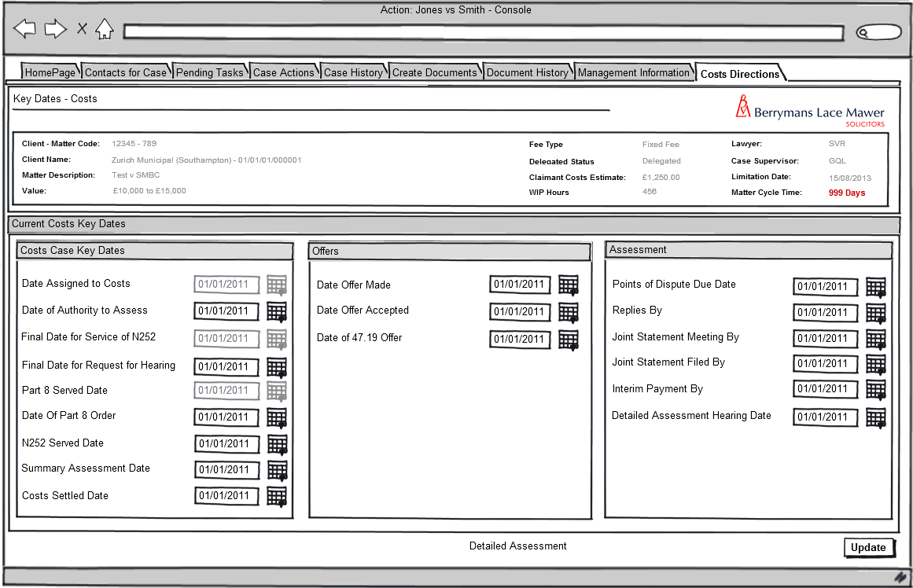
Fig 1: Costs Directions
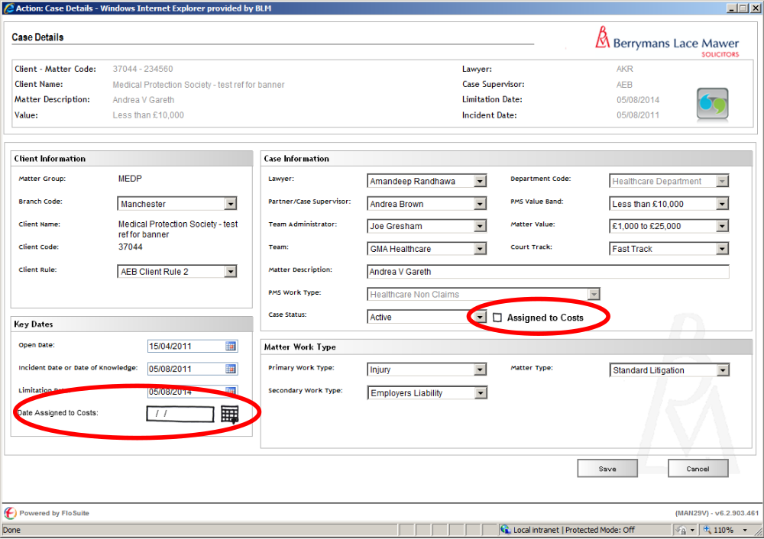

Fig 2: Assigned to Costs and Date Sssigned to Costs fields on Case Details Screen

    - Form Behaviour on Load

The screen should only be available if the Assigned to Costs Check box on the Case Details screen is checked (@pCase_CostsAssgn = 1) and should load with fields pre-populated with data previously entered using a new Stored Procedure: LTMM_CostsDirections_Fetch

    - Form Items:

Date Assigned to Costs – Label as stated with associated read only date field, populated from field CaseKeyDates_KeyDatesCode @pKeyDatesCode = ‘CostsAssignDate’

Date of Authority to Assess – Label as stated with associated date picker, value to be saved to CaseKeyDates table with @pKeyDatesCode = ‘CostsAuthAss’

Final Date for Notice of Commencement (N252) – Label as stated with associated date picker, value to be saved to CaseKeyDates table with @pKeyDatesCode = ‘CostsN252By’

Final Date for Request for Hearing (N258) – Label as stated with associated date picker, value to be saved to CaseKeyDates table with @pKeyDatesCode = ‘CostsN258By’

Part 8 Served Date – Label as stated with associated read only date field, populated from field ‘PartEight_SvdDate’

Date of Part 8 Order – Label as stated with associated date picker, value to be saved to CaseKeyDates table with @pKeyDatesCode = ‘Prt8OrderDte’

N252 Date of Service – Label as stated with associated date picker, value to be saved to CaseKeyDates table with @pKeyDatesCode = ‘N252DteSvd’

N258 Date of Service – Label as stated with associated date picker, value to be saved to CaseKeyDates table with @pKeyDatesCode = ‘N258DteSvd’

Summary Assessment Date – Label as stated with associated date picker, value to be saved to CaseKeyDates table with @pKeyDatesCode = ‘SumAsstDte’

Date Offer Made – Label as stated with associated date picker, value to be saved to CaseKeyDates table with @pKeyDatesCode = ‘OfferDate’

Date Offer Accepted – Label as stated with associated read only date field, populated from field CaseKeyDates_KeyDatesCode @pKeyDatesCode = ‘CostsOffAccept’

Date of 47.19 Offer – Label as stated with associated read only date field, populated from field CaseKeyDates_KeyDatesCode @pKeyDatesCode = ‘CostsAssign’

Date Assigned to Costs? – Label as stated with associated read only date field, populated from field CaseKeyDates_KeyDatesCode @pKeyDatesCode = ‘CostsAssign’

Date Assigned to Costs? – Label as stated with associated read only date field, populated from field CaseKeyDates_KeyDatesCode @pKeyDatesCode = ‘CostsAssign’

    - Form Behaviour on Save

Values to be saved to new fields using stored procedure dbo.LTMM_Case_Save (requires amendment):

dbo.Case_CostsAssgn (Bit, NULL), and

dbo.CaseKeyDates_Date (smalldatetime, NULL) with @pKeyDatesCode ‘AssndToCosts’

Selection of the Assigned to Costs? Check Box will create the following new reminder tasks using stored Procedure dbo.AppTask_CreatePending:

“Enter Claimant Solicitor/External Costs Draftsperson Details in Matter contacts” immediately for Team Administrator

“Enter BLM Costs Draftsperson’s Details” immediately for Team Admin

“Update Costs Key Dates” immediately for Team Administrator

“Carry out Part 8 Assessment” for 3 Months from the Date Assigned to Costs for the Costs Draftsperson in the Matter

Where Client ID is not one of Zurich or Ecclesiastical (@Case_GroupCode is NOT ‘ZUR’)

“Draft Costs Negotiation Advice To Client” immediately for the Costs Draftsperson in the Matter
]
Where the Client ID is Zurich or Ecclesiastical (@Case_GroupCode = ‘ZUR’).

“Draft Costs Negotiation Attendance Note” immediately for the Costs Draftsperson in the Matter

The system should record a history line to table dbo.AppTask: “Case assigned to Costs on <CostsAssgnDate>”

Return to Pending Tasks Screen

    - Form Behaviour on Cancel

Return to Matter Landing Page

  - Allocate BLM Costs Draftsperson as Lawyer in the Matter (Task without Form)

    - Task Behaviour on Select

Load Case Details Screen

  - Enter Claimant Solicitor/External Costs Draftsperson Details in Matter contacts (Task without Form)

    - Task Behaviour on Select

Load Contacts for Case Screen

  - Update Costs Key Dates

Fig 2: Costs Key Dates Screen

    - Form Availability

This form should be loaded on selection of the Team Administrator Task “Update Costs Key Dates” From the Pending Tasks screen, or ad-hoc from selection of the Costs Directions Tab in the Case Banner.

Tab should only be visible where the value in dbo.Case_CostsAssgn is not null – i.e. where the Case Assigned to Costs Checkbox is selected in the Case Details Screen

    - Form Behaviour on Load

The form should load as shown with any previously captured dates pre-populated using new Fetch: LTMM_CostsKeyDates_Fetch.

    - Form Items

Date Assigned to Costs – Label as stated with associated Date Picker, Read only associated with dbo.CaseKeyDates_Date (smalldatetime, NULL) with @pKeyDatesCode ‘AssndToCosts’ in LTMM_CostsKeyDates_Fetch.

Date of Authority to Assess -

Final Date For Lodgement – Label as stated with associated Date Picker associated with CaseKeyDates_Date (smalldatetime, NULL) with @pKeyDatesCode ‘LodgeDte’ pre-populated where value already exists using LTMM_CostsKeyDates_Fetch

Date N252 Due By – Label as stated with associated Date Picker associated with CaseKeyDates_Date (smalldatetime, NULL) with @pKeyDatesCode ‘N252Due’ pre-populated where value already exists using LTMM_CostsKeyDates_Fetch

Date Complete Part 8 By – Label as stated with associated Date Picker associated with CaseKeyDates_Date (smalldatetime, NULL) with @pKeyDatesCode ‘Part8DueBy’ pre-populated where value already exists using LTMM_CostsKeyDates_Fetch

Submit N258 By – Label as stated with associated Date Picker. Value to be saved to table CaseKeyDates with @pKeyDatesCode ‘N258By’ pre-populated where value already exists using LTMM_CostsKeyDates_Fetch

Date N252 Received – Label as stated with associated Date Picker. Value to be saved to table CAseKeyDates with @pKeyDatesCode ‘N252Recd’ pre-populated where value already exists using LTMM_CostsKeyDates_Fetch

Date Part 8 Order Received – Label as stated with associated Date Picker. Value to be saved to table CaseKeyDates with @pKeyDatesCode ‘OrderRcd’ pre-populated where value already exists using LTMM_CostsKeyDates_Fetch

    - Form Behaviour on Save

If Approve Draft Offer = “Yes”:

Schedule “Check Offer Acceptance” for 14 days time for Team Admin using stored Procedure dbo.AppTask_CreatePending

Set “Review Draft Offer” task as Complete

Record history line to table dbo.AppTask “Draft Costs Offer Approved on <Today’s Date>”

If Approve Draft Offer = “No”:

Reschedule “Review Draft Offer” for 3 days time for Supervisor using stored Procedure dbo.AppTask_CreatePending

Record history line to table dbo.AppTask “Draft Costs Offer Not Approved on <Today’s Date>”

    - Form Behaviour on Cancel

Return to Pending Tasks Screen

  - Draft Costs Negotiation Advice to Client (Task without Form)

    - Task Behaviour on Select

Produce Draft Costs Negotiation Attendance Note for Costs Draftsperson in the Matter to edit

Schedule “Review Draft Offer” immediately for Costs Supervisor/Team Leader

  - Draft Costs Negotiation Attendance Note (Task without form)

    - Task Behaviour on Select

Produce Costs Negotiation Advice to Client Letter for Costs Draftsperson in the Matter to edit

Schedule “Review Draft Offer” immediately for Costs Supervisor/Team Leader

  - Review Draft Offer

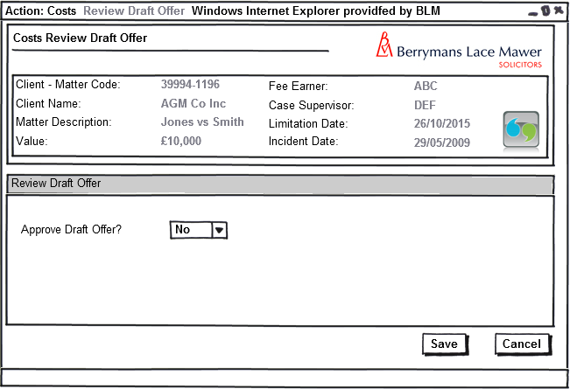
Fig 2: Review Draft Offer (Form 1):

    - Form Availability

This form should only be available from selection of the Team Leader/Supervisor task “Review Draft Offer” from the Pending Actions Screen

    - Form Behaviour on Load

The form should load as shown without any pre-population of data.

    - Form Items

Approve Draft Offer – Label as stated with associated mandatory Combo Box having the following options (Populated using LTMM_LookupCodes_Fetch with @LookupTypeCode = YesNo”, @BlankRow = 1):

  - Yes
  - No

Default to Blank

Value to be saved to new field in table: dbo.Costs_ApproveOffer (Bit, NULL)

    - Form Behaviour on Save

If Approve Draft Offer = “Yes”:

Schedule “Check Offer Acceptance” for 14 days time for Team Admin using stored Procedure dbo.AppTask_CreatePending

Set “Review Draft Offer” task as Complete

Record history line to table dbo.AppTask “Draft Costs Offer Approved on <Today’s Date>”

If Approve Draft Offer = “No”:

Reschedule “Review Draft Offer” for 3 days time for Supervisor using stored Procedure dbo.AppTask_CreatePending

Record history line to table dbo.AppTask “Draft Costs Offer Not Approved on <Today’s Date>”

    - Form Behaviour on Cancel

Return to Pending Tasks Screen

Task “Review Draft Offer” remains outstanding

  - Offer

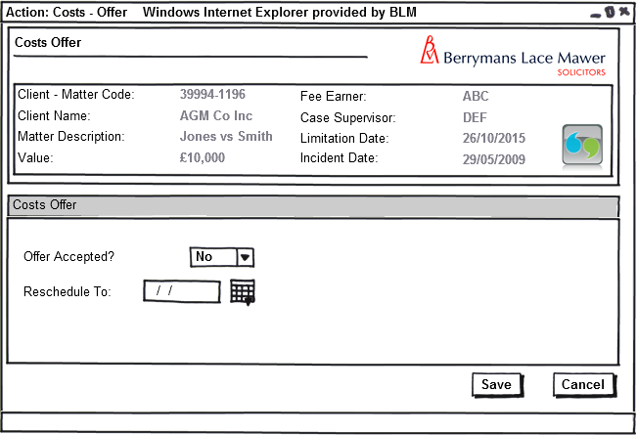

Fig 3: Offer (Form 2)

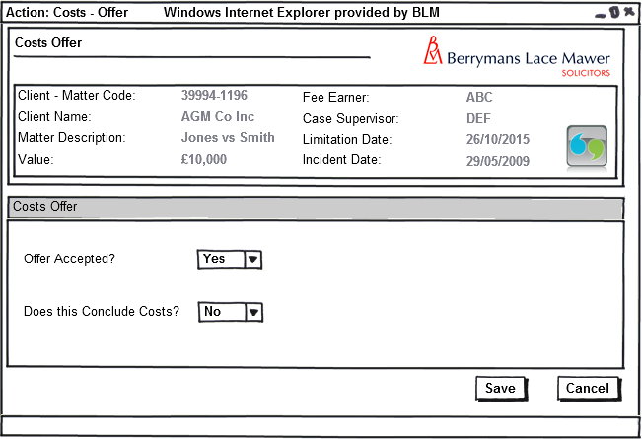
Fig 4: Costs Concluded? (Form 2)

    - Form Availability

Form should only be launched on selection of the task “Check Offer Acceptance” from the Pending Tasks screen.

    - Form Behaviour On Load

The form should load without any pre-population of data

    - Form Items

Offer Accepted? – Label as stated with associated Mandatory Combo box having the following options (Populated using LTMM_LookupCodes_Fetch with @LookupTypeCode = “YesNo”, @BlankRow = 1):
  - Yes
  - No

Default to Blank

Value to be saved to Dbo.Costs_AcceptOffer

Reschedule To: - Label as stated with associated Date Picker. Only visible if value selected in Offer Accepted = “No”

Value to be saved to dbo.Costs.AcceptResched

Does this Conclude Costs? – Label as stated with associated Mandatory Combo box if visible having the following options (Populated using LTMM_LookupCodes_Fetch with @LookupTypeCode = “YesNo”, @BlankRow = 1):
  - Yes
  - No

Default to Blank

Value to be saved to Dbo.Costs_Conclude

Field only visible if “Offer Accepted?”= <Yes>

    - Form Behaviour on Save

IF: Offer Accepted = “No”
AND Reschedule To: = “DATE”

Schedule “Check Offer Acceptance” for value entered in Reschedule To: field for Team Admin using stored Procedure dbo.AppTask_CreatePending

Save values to dbo.Costs using new stored procedure dbo.LTMM_Costs_Save

Task “Check Offer Acceptance” remains outstanding

Record history line to table dbo.AppTask “Offer Acceptance re-scheduled for <AcceptReschedDate>”

Return to Pending Tasks Screen.

IF: Offer Accepted = “No”
AND Reschedule To: = “No date”

Schedule “Detailed Assessment Process” immediately for Costs Draftsperson in the Matter using stored Procedure dbo.AppTask_CreatePending

Save values to dbo.Costs using new stored procedure dbo.LTMM_Costs_Save

Record history line to table dbo.AppTask

Task “Check Offer Acceptance” remains outstanding

IF: Offer Accepted = “Yes”
AND Costs Concluded = “No”

Schedule “Draft Advice to Client” or “Draft Offer Attendance Note” immediately for Costs Draftsperson in the Matter, depending upon whether the Client is Zurich or Ecclesiastical, using stored Procedure dbo.AppTask_CreatePending

Save values to dbo.Costs using new stored procedure dbo.LTMM_Costs_Save

Mark Task “Check Offer Acceptance” as Complete.

Record history line to table dbo.AppTask “Offer Accepted, Costs not concluded on <today’s date>”

Return to Pending Tasks Screen.

IF: Offer Accepted = “Yes”
AND Costs Concluded = “Yes”

Schedule “MI Update Completed” Task for Costs Draftsperson in the Matter using stored Procedure dbo.AppTask_CreatePending

Save values to dbo.Costs using new stored procedure dbo.LTMM_Costs_Save

Mark task “Check Offer Acceptance” as complete.

Record history line to table dbo.AppTask “Offer Accepted & Costs Concluded on <today’s date>”
Return to Costs MI Screen for the Matter

    - Form Behaviour on Cancel

Return to Pending Tasks Screen – Task “Check Offer Acceptance” remains outstanding

  - MI Update Completed (Task without form)

    - Task Behaviour on Select

Produce Costs Internal memo for Costs Draftsperson in the Matter to edit

Mark Task “MI Update Completed” as complete

Workflow

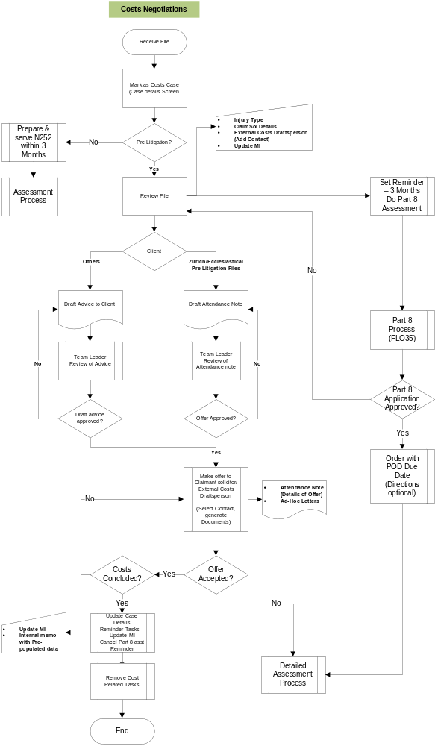
  - Costs Negotiation

Fig – Costs Negotiations Process

Navigation

  - Where will the Flow be launched from

The flow for Costs Negotiations will be launched from the Case Details screen:

- Upon the user Selecting the Assigned to Costs Check Box with a Yes Value, the system will schedule a task to be completed in the Case Pending Tasks “Process Part 8 Claim. Upon selection of that task the Process Part 8 Form will be launched
- The Flow can also be launched by a user selecting “Part 8 Claim” from the Ad-Hoc Tasks list.

  - Where should the Flow return to

- See Each Form for flow returns

SQL Tables

  - Tables

    - New Data Table in Database: dbo.Costs

Add field list with types (I know this is in the fields section but it avoids confusion)

Dbo.Costs_CostsID [int] IDENTITY(1,1) NOT NULL,
Dbo.Costs_CaseID [int] NOT NULL,

Dbo.Costs_CreateDate [smalldatetime] NOT NULL,
Dbo.Costs_CreateUser [nvarchar] (255) NOT NULL,

  - Lookup

New Lookup Values in dbo.KeyDatesType of:

dbo.KeyDatesType_Description | dbo.KeyDatesType _Code
Date Assigned to Costs | CostsAssign
Date N252 Due By | N252Due
Date Complete Part 8 by | Part8DueBy
Final Date For Lodgement | LodgeDte
Complete N258 By | N258By
Date Part 8 Order Received | OrderRcd
Date of Authority To Assess | AuthAssDte
Date N252 Received | N252Recd
Date of Consent Order | ConsOrder
Points of Dispute Due | PoDDue
Replies By | ReplBy
Joint Statement By | JtSttBy
Interim Payment By | IntPytBy
Hearing Date | CostsHrgDate
Date Offer Made | OffMadeDte
Date 47/19 Offer Made | 4719Dte
Date Offer Accepted | OffAcc
Detailed Assessment Date | DADte
Summary Assessment Date | SummAssDte
Costs Complete Date | CostsComp

New Lookup Values in dbo.LookUpType of:

dbo.LookupType_Description | dbo.LookupType _Code
Part 8 Type | Part8Type
Part 8 Source | Part8Source
Part 8 Hearing Attendee | Part8HrgAtt
Part 8 Hearing Outcome | Part8HrgOut
Part8 Costs | Part8Costs

New Lookup Values in dbo.LookUpCode of:

dbo.LookUpCode_LookupTypeCode | dbo.LookUpCode_Description | dbo.LookUpCode_Code
Part8Costs | No Cost Order Made | P8NOCOST
Part8Costs | For BLM | P8FORBLM
Part8Costs | Against BLM | P8AGAINSTBLM
Part8Costs | Costs in The Case | P8CIC

  - Fields & Forms

Label | Input Type | Table | Field Name | Field Value Type | Mandatory? | Rule | Form | Description
N/A | N/A | Dbo.Costs | _CostsID | [int] NOT NULL, | Yes | N/A | N/A | Part 8 ID (any case may have more than one Part 8 application)
N/A | N/A | Dbo.Costs | _CaseID | [int] NOT NULL, | Yes | N/A | N/A | Case ID

Stored Procedures

  - Fetch

New Stored Procedure:

- LTMM_Costs_Fetch

  - Save

New Stored Procedure:

- LTMM_Costs_Save

Tasks & Reminders

Task | Who On | Trigger | Behaviour on Select | Scheduling | Conditions/Parameters

Document Templates

Please list below details of any document required as part of this scope.

Status:  New / Existing / Replacement  (please state) | Received Document Name (from business) | Document File Name  (ie Document.dot) | Document Description  (as viewed on FloCase) | Template Description Code  (Code for auto description) | Template Group:  BLM/ Documents/ Court Doc/ Letters/ Other  (Please State)

/tmp/lo/0000.doc

